**Ocean Flow: Western Boundary Intensification and Ekman Transport**

**The Wavetable Project**

Did you know those ocean currents aren’t circular? In fact, they aren’t even close to being so, they are all, and this is genuinely the best word to describe it, ‘squished’. These wonky currents are also what cause an oceanic movement called Ekman transport. This is one of the primary ways water in the first 100m of the ocean is moved.

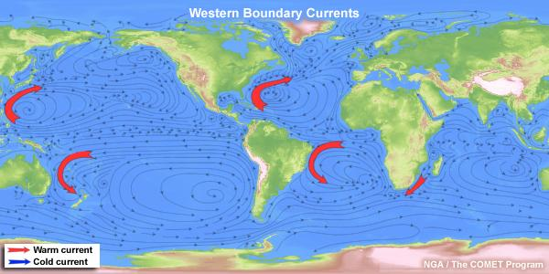

**Figure 1.** Visualization of western boundary intensification in the Gulf Stream, Kuroshio, E Australian, S Equatorial, and Aquinas gyres. [1]

**Before you begin, you will need:**

1. Wavetable
   1. With a RECTANGULAR tank
   2. With a SLOPED bottom (see instructions)
   3. With two fans blowing air in opposite directions over the surface of the water
2. Food dye
3. Dyed ice cube(s)
   1. 2-3 needed
4. Vacuum or turkey baster
5. Camera or iPhone
6. A computer that can connect to the camera. (Secondary Screen)

**Safety:**

1. Keep all exposed wires away from the water tank
2. Keep all long hair tied back and away from any spinning parts of the setup

**Experiment 1**

1. **To create western boundary currents, first, place the sloped bottom into the tank and fill it with water up until the max fill line. Gradually increase the RPM until it reaches** set 0.45**, and turn on the fans. Leave the tank rotating for 15 minutes to let the water settle.**

*While waiting for solid-body rotation, please read:*

In your previous experiments using the wavetable apparatus (namely the dye stirring lab), you may have noticed that the fluid in the tank moves in a circular pattern and is generally symmetrical. While this is good enough for basic understanding and lab work, the dynamics of the actual oceans are somewhat different. This lab will discuss and show why all of the great gyres (Kuroshio, gulf stream, etc.) all have what is called “western boundary intensification.” It was first discovered in 1948 by oceanographer Henry Stommel, and he postulated that the occurrence of western boundary currents was not due to specific geographical features, and could therefore be described using a much simpler setup. We shall attempt to do so in this lab.

Western boundary intensification is a phenomenon where the great ocean gyres are ‘squished’ towards their western edge. Some famous examples of this are in the Kuroshio current off the coast of Japan and the gulf stream on the eastern coast of the US. It is a phenomenon that occurs in all ocean gyres, but for the sake of simplicity, we shall use the gulf stream as an example to answer the question: Why do gyres tend to the west?

The simple answer is that the Coriolis force is weaker in lower latitudes and greater in higher latitudes due to the ‘differential rotation’ on Earth. The ‘differential rotation’ is derived from the fact that earth is a spinning spherical and not cylindrical planet. Were the earth to be cylindrical, the angular velocity at any two given points would be the same. But because the earth is a sphere, a person at the equator has a higher angular velocity than a person at a pole because they are both spinning at the same RPM but the person at the equator has to travel a farther distance during the same time period. This is called ‘differential rotation’.

But to answer this question fully, we need to take a look at two different, yet intertwined systems.

* Wind stress on the ocean
* Change in the magnitude of the Coriolis force

1. **Once the tank has been spinning at** set 0.45 **for 15 minutes, drop your food dye into the tank in two separate locations, with two separated colors. Make sure to drop a few drops in sequence, in the same location.**

*Begin to observe the behavior of the dye via your camera. Does the current in the tank seem to be ‘squished’ to one side? If so, what about the apparatus setup that might cause this?[1]*

| **Sources of Motion** | **Theories: How might these sources have created what you are seeing? How might these have been recreated in the tank?** |
| --- | --- |
| Wind stress on the ocean |  |
| Change in the magnitude of the Coriolis force |  |

*After you have generated at least one theory for each source, read the following:*

As we have previously discussed, the winds in the northern hemisphere have a stronger eastward wind in the north and a stronger westward wind in the south. The friction between the wind and the ocean causes wind stress and creates a clockwise, wind-induced ocean gyre. But there must be forces opposing the wind stress or else the oceans would continue to accelerate, as they clearly do not. But more on this later—we first need to understand how wind stress affects ocean flow, which means learning about Ekman Layers!

**Ekman Layers**

The Ekman layer of a fluid is a thin boundary layer where a balance is established between the fluid’s viscous force, the force between a particle and the fluid moving past it, and Coriolis acceleration—acceleration experienced by water particles due to the earth’s rotation. First postulated by Swedish oceanographer Vagn Wilfrid Ekman after discussions regarding Norwegian explorer Fridtjof Nansen’s observations on the movement of icebergs, Nansen observed that icebergs moved not in the direction of the wind, but at 45° to it. He theorized that there must be a system by which the stress caused by the surface winds causes objects to move at ~45 degrees to the direction of the wind. Ekmans’ explanation for this phenomenon was later named ‘Ekman transport’, as the phenomenon originated from Ekman layers. An Ekman layer may occur anywhere with horizontal frictional stress. As such, there are two types of Ekman layers commonly observed—one on the ocean surface, caused by the drag from surface winds, and the other at the bottom of the ocean where frictional forces flow over rough surfaces. [5]

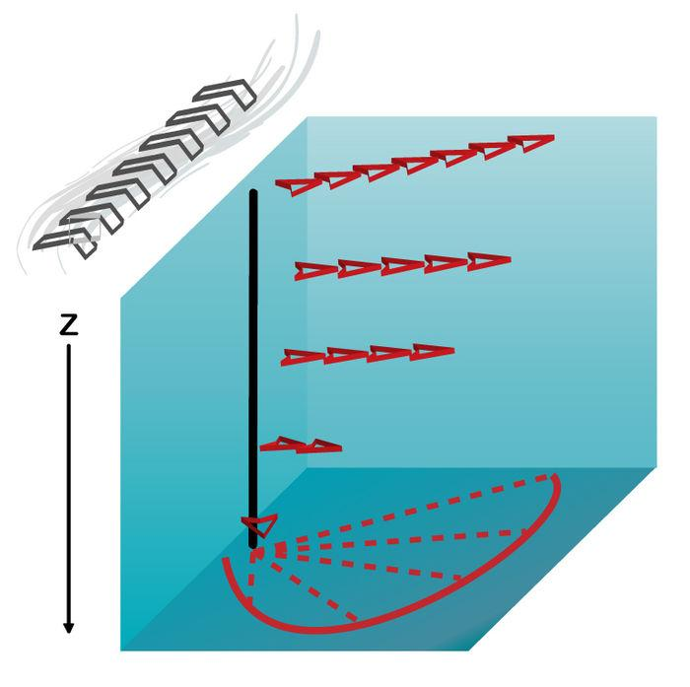

**Figure 2:** A simple diagram depicting the magnitude and direction of the Ekman layers’ velocity vectors in relation to geostrophic direction, where z represents the depth of the layer [4]

In both cases, the Ekman layer can be identified as the place where the flow gradually turns away from the geostrophic flow (geostrophic flow, is a type of current which occurs when the pressure gradient force and the Coriolis force cancel out to produce a current which flows along isobars, or lines of constant pressure. In the ocean, saltwater will tend to move from areas of high pressure to areas of low pressure, i.e. high sea level to low sea level. When the pressure gradient force is directly opposed by the Coriolis force, geostrophic flow can occur). In the oceans, the Ekman layers are usually found in the first 10 - 100m, where wind stress can have an effect on the water.

**Now, back to the ‘squished’ currents**

As we said earlier, there must be a force(s) opposing the wind stress or else the oceans would continue to accelerate into a gigantic maelstrom—possibly one with the actual ability to swallow ships whole.

The opposing force is the Coriolis force. It slows down the angular velocity of the gyres, pushing the southward waters east and the northern waters west and so on and so forth. But as we have established, the Coriolis force is not constant, and this fact that it cannot slow down some of the currents as much as it does others is precisely why currents are ‘squished’ against their western boundary and not the east.

The stronger Coriolis force in the north diverges the flow of the ocean gyre southward before all of it reaches (in this particular case) the coast of Europe where it would be physically turned by the specific geography of the coastline. But, the waters farther south near the equator have a weaker Coriolis force and are therefore not pushed with as much ‘force’ northwards. The result of the weak Coriolis force is that the majority of the westward flow is redirected not by the Coriolis force, but by the coastline of the eastern rim of the Atlantic. The concentrated flow along this westward coastline when compared to the eastern side of the Gulf stream gyre is called ‘western boundary intensification’. In figure 1 one can observe the ‘squished’ nature of the oceanic gyres along their western edges.

It is important to note, however, that the tendency for gyres to concentrate on their western edge is not a special trait derived from coastal geography, but rather a direct result of the different magnitudes of the Coriolis force derived from the spin of our planet. If our planet were to spin in the other direction, western boundary intensification would turn into eastern boundary intensification as the Coriolis force would flip directions (causing objects in the north to turn to the left and objects in the south to turn to the right, instead of the opposite which is observed on earth) and cause the aforementioned process to occur on the eastern edge of ocean gyres like the Gulf stream or the Kuroshio.

In this lab, we have simulated all of these factors (wind stress, geographical constraints, and earth's spin) by employing the same square tank, but with fans on the top providing with stress, and with a sloped bottom designed to simulate the sphericity of earth (see Figure 4.)

1. **After recording your data and observations, slowly reduce the speed of the turntable and empty the tank. Congratulations, this is the end of this course!!** [🥳](https://emojipedia.org/partying-face/)[🎉](https://emojipedia.org/party-popper/)🎆🎊🍾🙌㊗️

**Appendix**

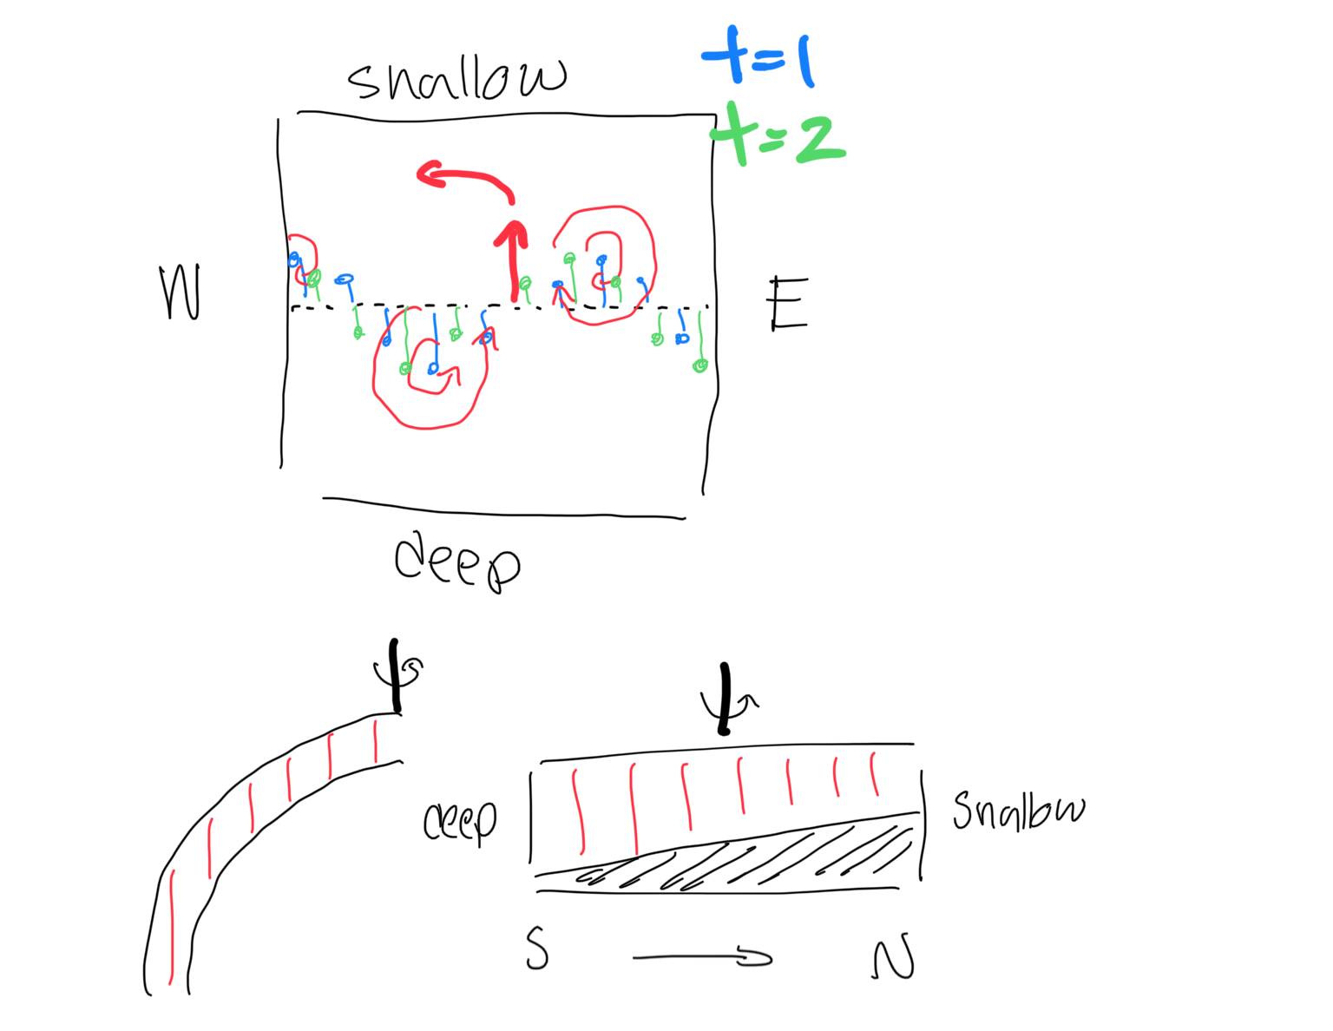

**Figure 3.** This shows why the shallow side of the tank is the north and the shallower side the south. From this, we can show that the waves do in fact propagate westward, not east.

**Examples**

**Glossary**

* Coriolis Force
  + A force derived from the differential rotation of the earth. Forces objects moving north in the northern hemisphere to the right, and objects moving north in the southern hemisphere to the left and vice versa for the opposing directions.
* Wind stress
  + The stress on the surface of the ocean caused by wind
* Oceanic gyres
  + Groups of rotation ocean currents
* Angular velocity
  + How fast an object rotates or spins around a specified axis
* Kuroshio & Gulf stream
  + Example of currents with western boundary intensification

**References**

1. Libretexts. “Ekman Layers.” *Geosciences Libretexts*, https://geo.libretexts.org/Bookshelves/Sedimentology/Book%3A_Introduction_to_Fluid_Motions_and_Sediment_Transport_(Southard)/07%3A_Flow_in_Rotating_Environments/7.06%3A_Ekman_Layers.
2. MIT. “Ekman Layers: Introduction.” *Weather in a Tank*, http://weathertank.mit.edu/links/projects/ekman-layers-introduction.
3. NASA. “Ocean in Motion: Geostrophic Flow Background.” *Ocean Motion and Surface Currents,* http://oceanmotion.org/html/background/geostrophic-flow.htm
4. Wikipedia. “Ekman Layers.”*Wikipedia*, Wikimedia Foundation, 15 Jan. https://en.wikipedia.org/wiki/Ekman_layer
5. Science Direct. “Ekman Layers.” *Encyclopedia of Atmospheric Sciences*, https://www.sciencedirect.com/topics/earth-and-planetary-sciences/ekman-layer
6. Vallis, Geoffrey K. *Climate and the Oceans*. Princeton University Press, 2012.
7. https://www.weather.gov/jetstream/longshort
8. https://en.wikipedia.org/wiki/Carl-Gustaf_Rossby
9. https://www.youtube.com/watch?v=nwyd5_8eIMM
10. https://physicsworld.com/a/summer-weather-extremes-linked-to-stalled-rossby-waves-in-the-jet-stream/
11. http://weathertank.mit.edu/links/projects/rossby-waves-introduction/rossby-waves-theory

1. See Appendix A